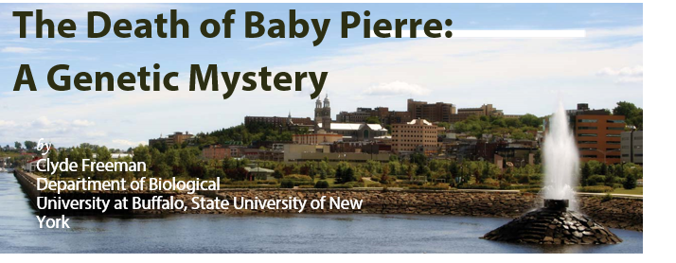

Part I
On March 7, 1964, the baby known as Pierre was born in a remote part of Quebec Province in Canada. He appeared to be a healthy six-pound twelve-ounce child, except he did not eat well. Over the weeks after his birth, he became progressively more lethargic, vomiting periodically. Most peculiarly, his urine smelled of rotten cabbage, and soon the smell permeated his clothes and body. By the time he was admitted to the hospital on September 14, his muscles were weak and his ribs were showing. Baby Pierre had only gained half a pound in the six months since his birth. Th e doctors kept him alive by feeding him through a tube threaded through his nose and into his stomach. He gained weight and strength for a while, then suddenly took a turn for the worse. On November 30, baby Pierre vomited
blood and died.
It soon became increasingly apparent that other babies in the Chicoutimi area of Quebec Province had similar symptoms, and people recalled similar deaths in this remote area 120 miles north of Quebec City. Some families lost several children to Pierre’s disease. In those families stricken, it soon became clear that the parents were normal, but about one quarter of their children were afflicted. Boys and girls were equally afflicted. Specialists soon concluded that all of the facts indicated that this was a genetic disorder.

If a genetic disorder was the cause, which answer is most likely correct? Explain the reason for your choice. (A) A pollutant is causing mutations.
- Multiple alleles are involved.
- Th e disease is caused by a dominant allele.
- Baby Pierre’s parents are homozygous for a recessive allele causing the disease.
- Th e disease is due to an autosomal recessive.

Part II
Baby Pierre and the other stricken children were victims of hereditary tyrosinemia. This is caused by an autosomal recessive disease. Th e children lacked the normal gene which produces a liver enzyme that breaks down the amino acid tyrosine. Without the enzyme, tyrosine builds up in the liver and kidneys leading to the cabbage-like smell of the urine. Lethal side-effects follow. (A liver transplant is the only long-term treatment of the disease as of 1997.)
Both parents avoid this fate because, although they carry one copy of the defective gene, they carry a normal gene which produces more than enough enzyme for normal liver function. Th e parents are unwitting carriers of the disease.
In genetic terminology they are heterozygotes, while Baby Pierre was a homozygous recessive.
Below is a pedigree of three generations of Canadians.
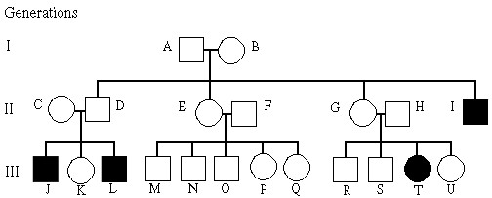

Questions
- Using the symbols of “a” for recessive allele and “A” for the dominant normal allele write the genotype for the following individuals: A, D, E, I, K and R?
- Is the above pedigree consistent with a sex-linked trait?
- What is the likelihood that female K will have a normal child if she marries a normal person who is a carrier for tyrosinemia?
- What is the likelihood of female K having a normal child if she marries her cousin M?
- From the answers below, what is the most likely reason for the large number of tyrosinemia cases in Chicoutimi? Explain the reason for your answer.
  - A high mutation rate.
  - A selective advantage for tyrosinemia in this part of Quebec.
  - Founder effect.
  - Nutritional patterns in the people; large quantities of tyrosine in the diet.
  - Pleiotropy where the allele for tyrosinemia has beneficial effects as well as harmful effects.
- Th e Hardy-Weinberg equation allows us to make some calculations about the local population.
  - What is the frequency of “aa” individuals?
  - What is the frequency of the “a” allele in the gene pool?
  - What is the frequency of the “A” allele in the gene pool?
  - What is the frequency of heterozygous individuals?
  - Assuming random breeding, what are the chances that two carriers will marry?

