Concept map activity!

Please use the vocabulary words that are on the list in the center of your table.

Pick as many words are you feel comfortable trying to connect, but this time try and choose up to 8 words (and from different units!!) to put in your concept map. Please include the definitions of each of the words you are using in your concept map.
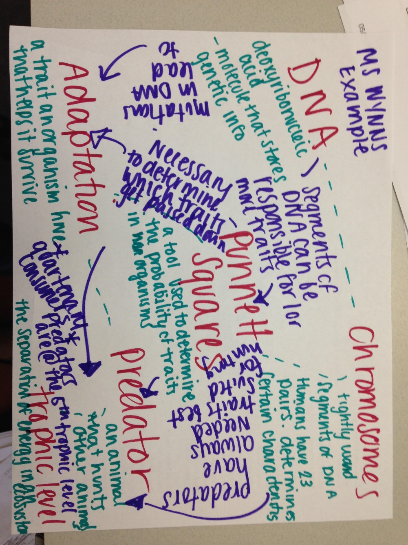
Make sure your concept map shows connections between the vocab word next to it, but also as many vocab words in the concept map as possible! See the picture below
.

Leave the concept map on my desk if you want some feedback on the connections you are making.

