Dissection Guide
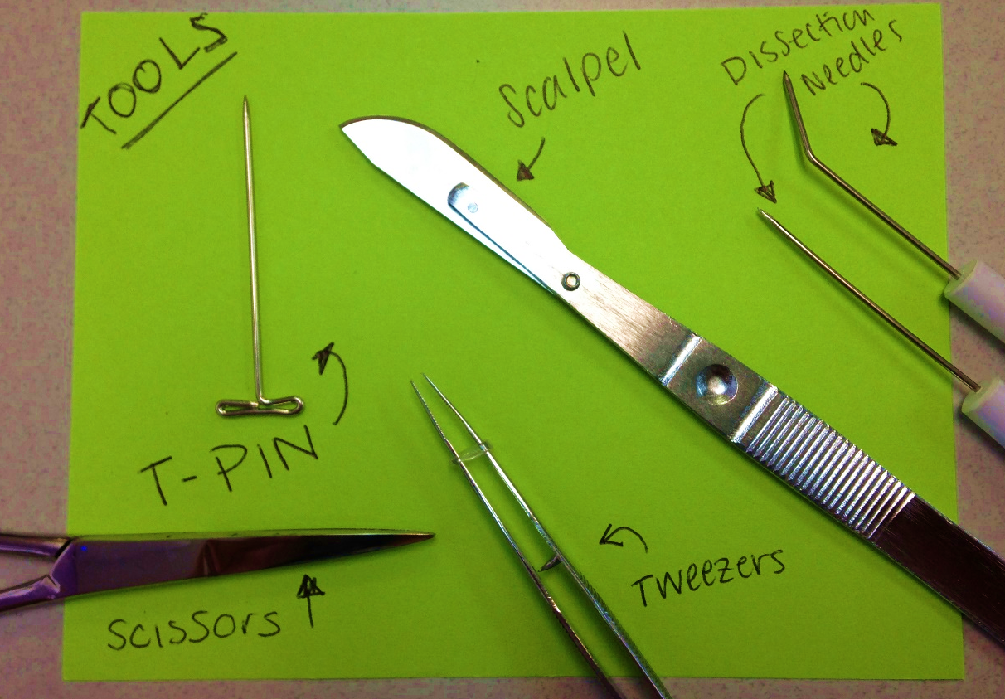
Before we begin dissections next week, we must go through the proper techniques and tools necessary to neatly dissect, view and remove organs of the animal you have chosen.

The picture above shows the tools you will be using throughout the dissection they include:
- T-Pins- used to pin parts of the animal in place to maintain a clear view of the internal organs inside

- Scissors- Used to cut through tough materials and separate parts of the internal organs from one another.

- Scalpels- Very sharp instruments used to slice through skin, ligaments and connective tissue. Please be careful when using the scalpel and always keep a secure cutting surface. NOTE: Most tissues can be cut with a scissors and not with a scalpel, always try with scissors first before using the scalpel. When using Scalpel cut away from yourself and others with the blade facing down

- Dissection Needles- Used to lift, or hold pieces of the animal in place while observing different levels or systems of the animals’ body.

- Tweezers- Used to remove organs or other pieces of tissue from the body.
Now let’s think about the animal as whole. Watch the videos associated with dissecting your particular animal(s). take notes on the video as you and your group watches them and answer the following questions.
What are noticeable characteristics from the various body systems of this animal? How does the structure influence the function?
- Digestive system?

- Integumentary system (Skin/hair/nails)?

- Nervous System?

- Digestive System/ Urinary system?

- Circulatory System?

- Skeletal System?

What trait is most useful to this animal?

What do you think caused the development of this trait in the animal?

After watching the videos related to general dissection techniques and your animal(s) dissection write down four things that you need to keep in mind throughout our dissection next week:
1.
2.
3.
4.

