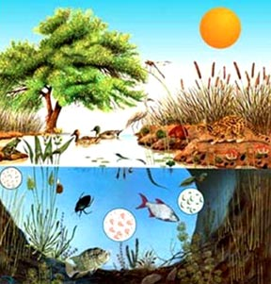
Ecology Game
Objective: Create an ecology focused game to best demonstrate your knowledge of the interconnected relationships between organisms in an ecosystem.
Your game must follow these four requirements
- It must be able to be played with 3+ players.
- It must follow a realistic ecosystem (for example, polar bears, sharks, and kangaroos cannot all coexist in your game)
- It must have at least two trophic levels represented.
- Changes in population must be quantifiable (aka graphable).
  - Look to the African Lions simulation, the rabbits excel simulation, the Notecard simulation or your deer/wolf graph for inspiration on how populations can change over time
Use the following Diagrams below to brainstorm some ideas for your group’s game.
Trophic Levels in your Ecosystem
Vocabulary Words to include
Trophic Levels
Ecological Succession
Carrying Capacity
Logistic Growth
Exponential Growth
Biotic Factors
Abiotic Factors
Producers
1°-4° Consumers
Decomposers
Birth/Death Rate

Suggestions from Ms. Wynn:
-Pick a number of organisms to start with and figure out a creative way to increase the population over time
-It’s a game, so get creative with the cards, the board your game is played on, or the actions that must be completed each round.
-Games are always more fun when random events occur—this seems like a great way to include some of the biotic and abiotic factors that always impact ecosystems

Now answer the following questions to help your group brainstorm some initial ideas

- What format will you use for your game (board game, card game, simulation, computer game?)

- What ecosystem will you represent? What animals from that ecosystem will you include?

- What outside factors will you include in your game?

- How will the game work? Now is the time to start writing the rules or directions.

- What materials will you need in order to make your game?

****Once you have completed this handout with your group check in with Ms. Wynn and get approval to start making your game!*****

