Section #1 Observations and Inferences: Look at the following graphs and respond to the questions that follow each graph. Use complete sentences.
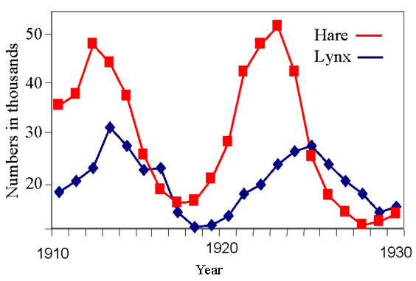

- What is the graph showing?

- What are two observations you can make about the hare population?

- What are two observations you can make about the lynx population?

- What are two inferences you can make from these observations?

- Name three factors that might affect the population of this ecosystem, describe whether they are biotic or abiotic.

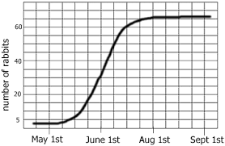
Rabbit population over time

- What kind of growth is being described in the graph?

- What is this phenomenon known as?

- What might be three limiting factors to the growth of the rabbit population?

- Predict what will happen in the rabbit population if there were no limiting factors.

Draw an example of exponential growth in the space below, and then give a realistic example of a species that might undergo exponential growth.
Section # 2 Information Analysis: Read the following article and respond to the prompt that follows.

Big Trouble Looms For California Salmon — And For Fishermen
Updated November 6, 20154:32 PM ET ALASTAIR BLAND

The West Coast's historic drought has strained many Californians — from farmers who've watched their lands dry up, to rural residents forced to drink and cook with bottled water. Now, thanks to a blazing hot summer and unusually warm water, things are looking pretty bad for salmon, too – and for the fishermen whose livelihoods depend on them. Preliminary counts of juvenile winter-run Chinook are at extreme low levels. These are salmon that are born during the summer in California's Sacramento River and begin to swim downstream in the fall.
Unusually warm water in recent months has caused high mortality for the young salmon, which are very temperature sensitive in their early life stages. Most years, about 25 percent of the eggs laid and fertilized by spawning winter-run fish survive. This summer and fall, the survival rate may be as low as 5 percent, according to Jim Smith, project leader with the U.S. Fish and Wildlife Service's Red Bluff office.
Worse, it's the second year in a row this has happened. Most Chinook salmon live on a three-year life cycle, which means one more year like the last two could essentially wipe out the population. To protect them, fishing for Chinook in the ocean may be restricted in the years ahead, until winter fish born in 2014 and 2015 have become big enough to bite a baited hook. The hope is that the few young fish that survived the recent warm-water die-offs will make it through adulthood and eventually return to the river to spawn.
Sacramento River Chinook are already protected by law. It's mostly the Chinook salmon of the relatively abundant fall run — a genetically distinct strain — that wind up in the fish boxes and coolers of California's commercial and recreational fishermen. The state's salmon fishery has been estimated to be worth $1.4 billion, with the fish finding their way into markets and restaurants.

The trouble is, winter born and fall born Salmon are impossible to tell apart by eye. In fact, many of the protected fish are almost certainly caught and killed every year. So, when estimated numbers of winter born fish drop too low, fishing restrictions for all ocean Chinook in certain regions along the California coast may be imposed to protect them.

Bay Area commercial salmon fisherman Mike Hudson says the situation is unfair. "We're all aware that fishermen haven't caused this problem," he says. "The way they manage water in the Central Valley has killed thousands of fish, and we might get shut down to save a few hundred."

The U.S. Bureau of Reclamation is required by federal law to make sure enough cold water is available throughout the year at the bottom of Lake Shasta, a large reservoir at the north end of the Sacramento Valley. This cold water is critical for successful salmon spawning in the river below. For fertilized Chinook eggs, water temperatures in the high 50s and up can be lethal. Temperatures in the low- to mid-50s are more ideal.
However, in 2014 and 2015, the bureau failed to meet basic temperature requirements for salmon. Louis Moore, public affairs specialist with the Bureau of Reclamation, says a faulty temperature gauge deep in the lake is to blame. Inaccurate readings, he says, threw off calculations in 2015. That resulted in too much water released from the reservoir early in the season and not enough cold water left later for the benefit of fish.
Even though farmers have had to cut back on their water use, favoring the farmers over the health of the Salmon population is illegal
.
If the drought persists through this winter, scientists believe that fish must be provided with generous flows or the correct water temperature while California farmers, who sold a record $54 billion in crops in 2014, must take one for the team.
"Because extinction is forever, and though economic losses for farmers are painful, they aren't forever," One fisherman said.

Write a paragraph that answers the following questions using 5-6 complete sentences.
1: What is the problem in the article?
2: What do you claim to be the cause of the problem?
3: What are three pieces of evidence that support your claim?

____________________________________________________________________________________
____________________________________________________________________________________
____________________________________________________________________________________
____________________________________________________________________________________
____________________________________________________________________________________
____________________________________________________________________________________
____________________________________________________________________________________
____________________________________________________________________________________
____________________________________________________________________________________
____________________________________________________________________________________
____________________________________________________________________________________
____________________________________________________________________________________
____________________________________________________________________________________
____________________________________________________________________________________
____________________________________________________________________________________
____________________________________________________________________________________
____________________________________________________________________________________
____________________________________________________________________________________
____________________________________________________________________________________
____________________________________________________________________________________

