Hardy Weinberg in practice

In this activity you will see how the Hardy –Weinberg Equilibrium keeps populations from being affected by natural selection. Remember, evolution does not occur in populations where the following is true:

1) There is a large breeding population

2) Mutations do not stay in the gene pool

3) Mates are chosen at random

4) There is no immigration or emigration

5) These is no natural selection- no one trait is more advantageous over the others

Scenario: We will be using both pretzel and cheddar goldfish crackers to see how Hardy Weinberg establishes a genetic equilibrium, and how selection for specific traits will shift this equilibrium toward evolution.

What exactly is the Hardy Weinberg equation? Turn to your notes and fill in the blanks below:

What does P stand for?

What does Q stand for?

P_____ + _____ PQ + Q²= ____

This equation means there is no _______ occurring.

Follow the instructions below in order to see the difference between Genetic Equilibrium and Micro-evolution.

Activity 1: Seeing the Hardy-Weinberg Equilibrium

Close your eyes and grab a small handful of Goldfish from the “lake”. Drop ten into your small container

Record the number of orange and brown Goldfish in Table 1 as Generation 1.

Close your eyes again and select three goldfish from your smaller container. You may eat these three or set them aside in the “dead fish bowl”

Return to the “lake” (your BIG container), close your eyes, and randomly select 3 new Goldfish to replace those that were eaten.

Students then record their new count of orange and brown Goldfish in Table 1 as Generation 2.

Repeat steps 3–5 until you have data for 5 generations.

Use the Hardy-Weinberg equation to calculate p, q, p2, q2, and 2pq for each generation.

Table 1: Genetic Equilibrium

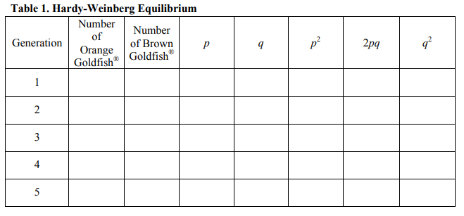

1
2
3
5
4

Activity 2: Micro evolution

1. Close your eyes and remove 10 Goldfish from the lake and place them in your smaller container

2. Record the number of orange and brown Goldfish in Table 2 as Generation 1.

3. Select and eat 3 brown Goldfish. (If you do not have 3 brown goldfish in your smaller container you may eat an orange goldfish; however, the point, is to select against the brown phenotype over a few generations.)

4. Close your eyes, and randomly select 3 new Goldfish to replace the ones that were eaten.

5. Record their new count of orange and brown Goldfish in Table 2 as Generation 2, and then, as before, select 3 brown ones to eat.

6. Repeat steps 3–5 until you have data for 5 generations.

7. Use the Hardy-Weinberg equation to calculate p, q, p 2 , q 2 , and 2pq.

Table 2: Micro-evolution
5
4
3
2
1

Reflection Questions:

What differences did you notice between the two activities?

How might we use hardy Weinberg to determine if populations are changing over time?

