http://ngm.nationalgeographic.com/print/2011/04/ocean-acidification/kolbert-text
The Acid Sea
The carbon dioxide we pump into the air is seeping into the oceans and slowly acidifying them. One hundred years from now, will oysters, mussels, and coral reefs survive?
By Elizabeth Kolbert
Owing to a quirk of geology, the sea around an island in Italy provides a window onto the oceans of 2050 and beyond. Bubbles of CO₂ rise from volcanic vents on the seafloor and dissolve to form carbonic acid. Carbonic acid is relatively weak; people drink it all the time in carbonated beverages. But if enough of it forms, it makes seawater corrosive. "When you get to the extremely high CO₂, almost nothing can tolerate that," Jason Hall-Spencer, a marine biologist from Britain's University of Plymouth, explains. The island, Castello Aragonese, offers a natural analogue for an unnatural process: The acidification that has taken place off its shore is occurring more gradually across the world's oceans, as they absorb more and more of the carbon dioxide that's coming from tailpipes and smokestacks.
Hall-Spencer has been studying the sea around the island for the past eight years, carefully measuring the properties of the water and tracking the fish and corals and mollusks that live and, in some cases, dissolve there. On a chilly winter's day I went swimming with him and with Maria Cristina Buia, a scientist at Italy's Anton Dohrn Zoological Station, to see the effects of acidification up close. We anchored our boat about 50 yards from the southern shore of Castello Aragonese. Even before we got into the water, some impacts were evident. Clumps of barnacles formed a whitish band at the base of the island's wave-battered cliffs. "Barnacles are really tough," Hall-Spencer observed. In the areas where the water was most acidified, though, they were missing.
We all dived in. Buia was carrying a knife. She pried some unlucky limpets from a rock. Searching for food, they had wandered into water that was too caustic for them. Their shells were so thin they were almost transparent. Bubbles of carbon dioxide streamed up from the seafloor like beads of quicksilver. We swam on. Beds of sea grass waved beneath us. The grass was a vivid green; the tiny organisms that usually coat the blades, dulling their color, were all missing. Sea urchins, commonplace away from the vents, were also absent; they can't tolerate even moderately acidified water. Swarms of nearly transparent jellyfish floated by. "Watch out," Hall-Spencer warned. "They sting."
Jellyfish, sea grass, and algae—not much else lives near the densest concentration of vents at Castello Aragonese. Even a few hundred yards away, many native species can't survive. The water there is about as acidified as the oceans as a whole are forecast to be by 2100. "Normally in a polluted harbor you've got just a few species that are weedlike and able to cope with widely fluctuating conditions," Hall-Spencer said once we were back on the boat. "Well, it's like that when you ramp up CO₂."
Since the start of the industrial revolution, enough fossil fuels—coal, oil, and natural gas—have been burned and enough forests cut down to emit more than 500 billion tons of CO₂. As is well known, the atmosphere has a higher concentration of CO₂ today than at any point in the past 800,000 years.
What is less well known is how carbon emissions are changing the oceans too. The air and the water constantly exchange gases, so a portion of anything emitted into the atmosphere eventually ends up in the sea. Winds quickly mix it into the top few hundred feet, and over centuries currents spread it through the ocean depths. In the 1990s an international team of scientists undertook a massive research project that involved collecting and analyzing more than 77,000 seawater samples from different depths and locations around the world. The work took 15 years. It showed that the oceans have absorbed 30 percent of the CO₂ released by humans over the past two centuries. They continue to absorb roughly a million tons every hour.
For life on land this process is helpful; every ton of CO₂ the oceans remove from the atmosphere is a ton that's not contributing to global warming. But for life in the sea the picture looks different. The head of the National Oceanic and Atmospheric Administration, Jane Lubchenco, a marine ecologist, has called ocean acidification global warming's "equally evil twin."
The pH scale, which measures acidity in terms of the concentration of hydrogen ions, runs from zero to 14. At the low end of the scale are strong acids, at the high end are strong bases. Pure, distilled water has a pH of 7, which is neutral. Seawater should be slightly basic, with a pH around 8.2 near the sea surface. So far CO₂ emissions have reduced the pH there by about 0.1. Like the Richter scale, the pH scale is logarithmic, so even small numerical changes represent large effects. A pH drop of 0.1 means the water has become 30 percent more acidic. If present trends continue, surface pH will drop to around 7.8 by 2100. At that point the water will be 150 percent more acidic than it was in 1800.
The acidification that has occurred so far is probably irreversible. Although in theory it's possible to add chemicals to the sea to counter the effects of the extra CO₂, as a practical matter, the volumes involved would be staggering; it would take at least two tons of base, for example, to offset a single ton of carbon dioxide, and the world now emits more than 30 billion tons of CO₂ each year. Meanwhile, natural processes that could counter acidification—such as the weathering of rocks on land—operate far too slowly to make a difference on a human time-scale. Even if CO₂ emissions were somehow to cease today, it would take tens of thousands of years for ocean chemistry to return to its pre-industrial condition.
Acidification has many effects. By favoring some marine microbes over others, it is likely to alter the availability of key nutrients like iron and nitrogen. For similar reasons it may let more sunlight penetrate the sea surface. By changing the basic chemistry of seawater, acidification is also expected to reduce the water's ability to absorb and muffle low-frequency sound by up to 40 percent, making some parts of the ocean noisier. Finally, acidification interferes with reproduction in some species and with the ability of others—the so-called calcifiers—to form shells and stony skeletons of calcium carbonate. These last effects are the best documented ones, but whether they will prove the most significant in the long run is unclear.
In 2008 a group of more than 150 leading researchers issued a declaration stating that they were "deeply concerned by recent, rapid changes in ocean chemistry," which could within decades "severely affect marine organisms, food webs, biodiversity, and fisheries." Warm-water coral reefs are the prime worry. But because carbon dioxide dissolves more readily in cold water, the impact may actually show up first closer to the Poles. Scientists have already documented significant effects on pteropods—tiny swimming snails that are an important food for fish, whales, and birds in both the Arctic and the Antarctic. Experiments show that pteropod shells grow more slowly in acidified seawater.
Will organisms be able to adapt to the new ocean chemistry? The evidence from Castello Aragonese is not encouraging. The volcanic vents have been pouring CO₂ into the water for at least a thousand years, Hall-Spencer told me when I visited. But the area where the pH is 7.8—the level that may be reached oceanwide by the end of the century—is missing nearly a third of the species that live nearby, outside the vent system. Those species have had "generations on generations to adapt to these conditions," Hall-Spencer said, "yet they're not there.
"Because it's so important, we humans put a lot of energy into making sure that the pH of our blood is constant," he went on. "But some of these lower organisms, they don't have the physiology to do that. They've just got to tolerate what's happening outside. And so they get pushed beyond their limits."
Fifty miles off the coast of Australia and half a world away from Castello Aragonese lies the equally tiny One Tree Island. One Tree, which actually has several hundred trees, is shaped like a boomerang, with two arms that stretch out into the Coral Sea. One Tree Island is part of the Great Barrier Reef, the world's largest reef complex, which stretches for more than 1,400 miles.
"Something like 25 percent of all species in the oceans spend at least part of their life in coral reef systems," Ken Caldeira, an expert on ocean acidification at the Carnegie Institution, said in an interview. "Corals build the architecture of the ecosystem, and it's pretty clear if they go, the whole ecosystem goes."
Coral reefs are already threatened by a wide array of forces. Rising water temperatures are producing more frequent "bleaching" events, when corals turn a stark white and often die. Overfishing removes grazers that keep reefs from being overgrown with algae. Agricultural runoff fertilizes algae, further upsetting reef ecology. In the Caribbean some formerly abundant coral species have been devastated by an infection that leaves behind a white band of dead tissue. Probably owing to all these factors, coral cover in the Caribbean declined by around 80 percent between 1977 and 2001.
Ocean acidification adds yet another threat, one that may be less immediate but ultimately more devastating to hard, reef-building corals. It undermines their basic, ancient structure—the stony skeleton that's secreted by millions upon millions of coral polyps over thousands of years.
Coral polyps are tiny animals that form a thin layer of living tissue on the surface of a reef. They're shaped a bit like flowers, with six or more tentacles that capture food and feed it to a central mouth. (Many corals actually get most of their food from algae that live and photosynthesize inside them; when corals bleach, it's because stress has prompted the polyps to expel those dark symbionts.) Each polyp surrounds itself with a protective, cup-shaped exoskeleton of calcium carbonate that contributes to the collective skeleton of the whole colony.
To make calcium carbonate, corals need two ingredients: calcium ions and carbonate ions. Acids react with carbonate ions, in effect tying them up. So as atmospheric CO₂ levels rise, carbonate ions become scarcer in the water, and corals have to expend more energy to collect them. Under lab conditions coral skeleton growth has been shown to decline pretty much linearly as the carbonate concentration drops off.
Slow growth may not matter much in the lab. Out in the ocean, though, reefs are constantly being picked at by other organisms, both large and small. (When I went snorkeling off One Tree Island, I could hear parrotfish chomping away at the reef.) "A reef is like a city," said Ove Hoegh-Guldberg, who used to direct the One Tree Island Research Station and now heads the Global Change Institute at Australia's University of Queensland. "You've got construction firms and you've got demolition firms. By restricting the building materials that go to the construction firms, you tip the balance toward destruction, which is going on all the time, even on a healthy reef. In the end you wind up with a city that destroys itself."
By comparing measurements made in the 1970s with those taken more recently, Caldeira's team found that at one location on the northern tip of the reef, calcification had declined by 40 percent. A different team using a different method has found that the growth of Porites corals, which form massive, boulderlike clumps, declined 14 percent on the Great Barrier Reef between 1990 and 2005.
Ocean acidification seems to affect corals' ability to produce new colonies as well. Corals can, in effect, clone themselves, and an entire colony is likely to be made up of genetically identical polyps. But once a year, in summer, many species of coral also engage in "mass spawning," a kind of synchronized group sex. Each polyp produces a beadlike pink sac that contains both eggs and sperm. On the night of the spawning all the polyps release their sacs into the water. So many sacs are bobbing around that the waves seem to be covered in a veil of mauve.
Selina Ward, a researcher at the University of Queensland, has been studying coral reproduction on Heron Island, about ten miles west of One Tree, for the past 16 years. Her results so far suggest that lower pH leads to declines in fertilization, in larval development, and also in settlement—the stage at which the coral larvae drop out of the water column, attach themselves to something solid, and start producing new colonies. "And if any of those steps doesn't work, you're not going to get replacement corals coming into your system," Ward said.
The reefs that corals maintain are crucial to an incredible diversity of organisms. Somewhere between one and nine million marine species live on or around coral reefs. These include not just the fancifully colored fish and enormous turtles that people visit reefs to see, but also sea squirts and shrimps, anemones and clams, sea cucumbers and worms—the list goes on and on. The nooks and crevices on a reef provide homes for many species, which in turn provide resources for many others.
Once a reef can no longer grow fast enough to keep up with erosion, this community will crumble. "Coral reefs will lose their ecological functionality," Jack Silverman, a member of Caldeira's team at One Tree, told me. "They won't be able to maintain their framework. And if you don't have a building, where are the tenants going to live?" That moment could come by 2050. Under the business-as-usual emissions scenario, CO₂concentrations in the atmosphere will be roughly double what they were in preindustrial times. Many experiments suggest that coral reefs will then start to disintegrate.
"Under business as usual, by 2500 are looking rather grim," Caldeira said. He paused for a moment. "I mean, they're looking grim already."
Corals, of course, are just one kind of calcifier. There are thousands of others. Crustaceans like barnacles are calcifiers, and so are echinoderms like sea stars and sea urchins and mollusks like clams and oysters. Coralline algae—minute organisms that produce what looks like a coating of pink or lilac paint—are also calcifiers. Their calcium carbonate secretions help cement coral reefs together, but they're also found elsewhere—on sea grass at Castello Aragonese, for instance. It was their absence from the grass near the volcanic vents that made it look so green.
Acidification makes all calcifiers work harder, though some seem better able to cope. In experiments on 18 species belonging to different taxonomic groups, researchers at the Woods Hole Oceanographic Institution found that while a majority calcified less when CO₂ was high, some calcified more. One species—blue mussels—showed no change, no matter how acidified the water.
"Organisms make choices," explained Ulf Riebesell, a biological oceanographer at the Leibniz Institute of Marine Sciences in Kiel, Germany. "They sense the change in their environment, and some of them have the ability to compensate. They just have to invest more energy into calcification. They choose, 'OK, I'll invest less in reproduction' or 'I'll invest less in growth.'" What drives such choices, and whether they're viable over the long term, is not known; most studies so far have been performed on creatures living for a brief time in tanks, without other species that might compete with them. "If I invest less in growth or in reproduction," Riebesell went on, "does it mean that somebody else who does not have to make this choice, because they are not calcifying, will win out and take my spot?"
Meanwhile, scientists are just beginning to explore the way that ocean acidification will affect more-complex organisms such as fish and marine mammals. Changes at the bottom of the marine food web—to shell-forming pteropods, say, or coccolithophores—will inevitably affect the animals higher up. But altering oceanic pH is also likely to have a direct impact on their physiology. Researchers in Australia have found, for example, that young clownfish—the real-life versions of Nemo—can't find their way to suitable habitat when CO₂ is elevated. Apparently the acidified water impairs their sense of smell.
During the long history of life on Earth, atmospheric carbon dioxide levels have often been higher than they are today. But only very rarely—if ever—have they risen as quickly as right now. For life in the oceans, it's probably the rate of change that matters.
To find a period analogous to the present, you have to go back at least 55 million years, to what's known as the Paleocene-Eocene Thermal Maximum or PETM. During the PETM huge quantities of carbon were released into the atmosphere, from where, no one is quite sure. Temperatures around the world soared by around ten degrees Fahrenheit, and marine chemistry changed dramatically. The ocean depths became so corrosive that in many places shells stopped piling up on the seafloor and simply dissolved. In sediment cores the period shows up as a layer of red clay sandwiched between two white layers of calcium carbonate. Many deepwater species of forami�nifera went extinct.
Surprisingly, though, most organisms that live near the sea surface seem to have come through the PETM just fine. Perhaps marine life is more resilient than the results from places like Castello Aragonese and One Tree Island seem to indicate. Or perhaps the PETM, while extreme, was not as extreme as what's happening today.
The sediment record doesn't reveal how fast the PETM carbon release occurred. But modeling studies suggest it took place over thousands of years—slow enough for the chemical effects to spread through the entire ocean to its depths. Today's rate of emissions seems to be roughly ten times as fast, and there's not enough time for the water layers to mix. In the coming century acidification will be concentrated near the surface, where most marine calcifiers and all tropical corals reside.
. It's still possible to avert the most extreme acidification scenarios. But the only way to do this, or at least the only way anyone has come up with so far, is to dramatically reduce CO₂emissions. At the moment, corals and pteropods are lined up against a global economy built on cheap fossil fuels. It's not a fair fight.

http://www.pmel.noaa.gov/co2/story/What+is+Ocean+Acidification%3F

What is Ocean Acidification?
A pH unit is a measure of acidity ranging from 0-14. The lower the value, the more acidic the environment. Becoming more acidic is a relative shift in pH to a lower value.
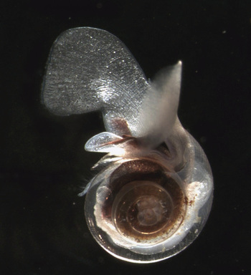
Pteropod Limacina Helicina. Courtesy of Russ Hopcroft, UAF.

The Chemistry
When carbon dioxide (CO₂) is absorbed by seawater, chemical reactions occur that reduce seawater pH, carbonate ion concentration, and saturation states of biologically important calcium carbonate minerals. These chemical reactions are termed "ocean acidification" or "OA" for short. Calcium carbonate minerals are the building blocks for the skeletons and shells of many marine organisms. In areas where most life now congregates in the ocean, the seawater is supersaturated with respect to calcium carbonate minerals. This means there are abundant building blocks for calcifying organisms to build their skeletons and shells. However, continued ocean acidification is causing many parts of the ocean to become undersaturated with these minerals, which is likely to affect the ability of some organisms to produce and maintain their shells.
Since the beginning of the Industrial Revolution, the pH of surface ocean waters has fallen by 0.1 pH units. Since the pH scale, like the Richter scale, is logarithmic, this change represents approximately a 30 percent increase in acidity. Future predictions indicate that the oceans will continue to absorb carbon dioxide and become even more acidic. Estimates of future carbon dioxide levels, based on business as usual emission scenarios, indicate that by the end of this century the surface waters of the ocean could be nearly 150 percent more acidic, resulting in a pH that the oceans haven’t experienced for more than 20 million years.

The Biological Impacts
Ocean acidification is expected to impact ocean species to varying degrees. Photosynthetic algae and seagrasses may benefit from higher CO₂ conditions in the ocean, as they require CO₂ to live just like plants on land. On the other hand, studies have shown that a more acidic environment has a dramatic effect on some calcifying species, including oysters, clams, sea urchins, shallow water corals, deep sea corals, and calcareous plankton. When shelled organisms are at risk, the entire food web may also be at risk. Today, more than a billion people worldwide rely on food from the ocean as their primary source of protein. Many jobs and economies in the U.S. and around the world depend on the fish and shellfish in our oceans.

Pteropods
The pteropod, or “sea butterfly”, is a tiny sea creature about the size of a small pea. Pteropods are eaten by organisms ranging in size from tiny krill to whales and are a major food source for North Pacific juvenile salmon. The photos below show what happens to a pteropod’s shell when placed in sea water with pH and carbonate levels projected for the year 2100. The shell slowly dissolves after 45 days. Photo credit: David Liittschwager/National Geographic Stock. Used with permission. All rights reserved. National Geographic Images.
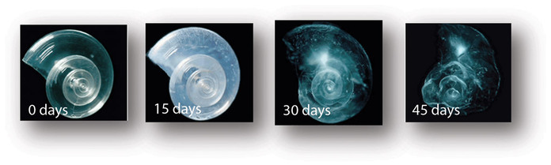

Shellfish
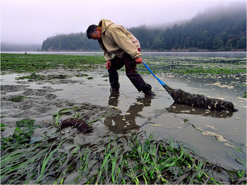
In recent years, there have been near total failures of developing oysters in both aquaculture facilities and natural ecosystems on the West Coast. These larval oyster failures appear to be correlated with naturally occurring upwelling events that bring low pH waters undersaturated in aragonite as well as other water quality changes to nearshore environments. Lower pH values occur naturally on the West Coast during upwelling events, but a recent observations indicate that anthropogenic CO₂ is contributing to seasonal undersaturation. Low pH may be a factor in the current oyster reproductive failure; however, more research is needed to disentangle potential acidification effects from other risk factors, such as episodic freshwater inflow, pathogen increases, or low dissolved oxygen. It is premature to conclude that acidification is responsible for the recent oyster failures, but acidification is a potential factor in the current crisis to this $100 million a year industry, prompting new collaborations and accelerated research on ocean acidification and potential biological impacts.
Photo: Freshly harvested oysters from Yaquina Bay, Oregon (Credit: NOAA)

Coral
Many marine organisms that produce calcium carbonate shells or skeletons are negatively impacted by increasing CO₂levels and decreasing pH in seawater. For example, increasing ocean acidification has been shown to significantly reduce the ability of reef-building corals to produce their skeletons. In a recent paper, coral biologists reported that ocean acidification could compromise the successful fertilization, larval settlement and survivorship of Elkhorn coral, an endangered species. These research results suggest that ocean acidification could severely impact the ability of coral reefs to recover from disturbance. Other research indicates that, by the end of this century, coral reefs may erode faster than they can be rebuilt. This could compromise the long-term viability of these ecosystems and perhaps impact the estimated one million species that depend on coral reef habitat. For more information on the impact of ocean acidification on coral, see NOAA's Coral Reef Watch website.

Ocean Acidification: An Emerging Global Problem
Ocean acidification is an emerging global problem. Over the last decade, there has been much focus in the ocean science community on studying the potential impacts of ocean acidification. Since sustained efforts to monitor ocean acidification worldwide are only beginning, it is currently impossible to predict exactly how ocean acidification impacts will cascade throughout the marine food chain and affect the overall structure of marine ecosystems. With the pace of ocean acidification accelerating, scientists, resource managers, and policymakers recognize the urgent need to strengthen the science as a basis for sound decision making and action.

http://www.latimes.com/world/la-me-ocean3aug03-story.html

Why Acidity Matters
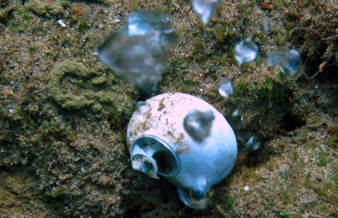
The acidic waters from the CO₂ seeps can dissolve shells and also make it harder for shells to grow in the first place.
Credit:
Laetitia Plaisance
Many chemical reactions, including those that are essential for life, are sensitive to small changes in pH. In humans, for example, normal blood pH ranges between 7.35 and 7.45. A drop in blood pH of 0.2-0.3 can cause seizures, comas, and even death. Similarly, a small change in the pH of seawater can have harmful effects on marine life, impacting chemical communication, reproduction, and growth.
The building of skeletons in marine creatures is particularly sensitive to acidity. One of the molecules that hydrogen ions bond with is carbonate (CO₃⁻²), a key component of calcium carbonate (CaCO₃) shells. To make calcium carbonate, shell-building marine animals such as corals and oysters combine a calcium ion (Ca⁺²) with carbonate (CO₃⁻²) from surrounding seawater, releasing carbon dioxide and water in the process.
Like calcium ions, hydrogen ions tend to bond with carbonate—but they have a greater attraction to carbonate than calcium. When two hydrogens bond with carbonate, a new molecule called bicarbonate (2HCO³⁻) is formed. Shell-building organisms can't extract the carbonate ion they need from bicarbonate, preventing them from using that carbonate to grow new shell. In this way, the hydrogen essentially binds up the carbonate ions, making it harder for shelled animals to build their homes. Even if animals are able to build skeletons in more acidic water, they may have to spend more energy to do so, taking away resources from other activities like reproduction. If there are too many hydrogen ions around and not enough molecules for them to bond with, they can even begin breaking existing calcium carbonate molecules apart—dissolving shells that already exist.
This is just one process that extra hydrogen ions—caused by dissolving carbon dioxide—may interfere with in the ocean. Organisms in the water, thus, have to learn to survive as the water around them has an increasing concentration of carbonate-hogging hydrogen ions.

Impacts on Ocean Life
The pH of the ocean fluctuates within limits as a result of natural processes, and ocean organisms are well-adapted to survive the changes that they normally experience. Some marine species may be able to adapt to more extreme changes—but many will suffer, and there will likely be extinctions. We can't know this for sure, but during the last great acidification event 55 million years ago, there were mass extinctions in some species including deep sea invertebrates. A more acidic ocean won’t destroy all marine life in the sea, but the rise in seawater acidity of 30 percent that we have already seen is already affecting some ocean organisms.

Coral Reefs
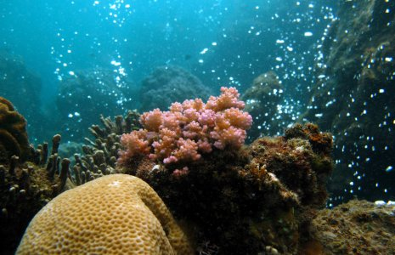
Branching corals, because of their more fragile structure, struggle to live in acidified waters around natural carbon dioxide seeps, a model for a more acidic future ocean.
Credit:
Laetitia Plaisance
Reef-building corals craft their own homes from calcium carbonate, forming complex reefs that house the coral animals themselves and provide habitat for many other organisms. Acidification maylimit coral growth by corroding pre-existing coral skeletons while simultaneously slowing the growth of new ones, and the weaker reefs that result will be more vulnerable to erosion. This erosion will come not only from storm waves, but also fromanimals that drill into or eat coral. By the middle of the century, it’s possible that even otherwise healthy coral reefs will be eroding more quickly than they can rebuild.
Acidification may also impact corals before they even begin constructing their homes. The eggs and larvae of only a few coral species have been studied, and more acidic water didn’t hurt their development while they were still in the plankton. However, larvae in acidic water had moretrouble finding a good place to settle, preventing them from reaching adulthood.
How much trouble corals run into will vary by species. Some types of coral can use bicarbonateinstead of carbonate ions to build their skeletons, which gives them more options in an acidifying ocean. Some can survive without a skeleton and return to normal skeleton-building activitiesonce the water returns to a more comfortable pH. Others can handle a wider pH range.
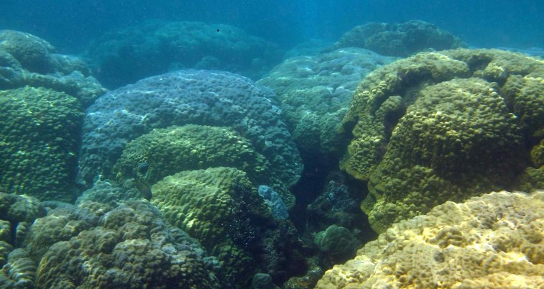
Close to the volcanic CO₂ seeps, the vast diversity of corals that exists in less-acidic waters is replaced by a "monoculture" of boulder corals.
Credit:
Laetitia Plaisance
Nonetheless, in the next century we will see the common types of coral found in reefs shifting—though we can't be entirely certain what that change will look like. On reefs in Papua New Guinea that are affected by natural carbon dioxide seeps, big boulder colonies have taken over and the delicately branching forms have disappeared, probably because their thin branches are more susceptible to dissolving. This change is also likely to affect the many thousands of organisms that live among the coral, including those that people fish and eat, in unpredictable ways. In addition, acidification gets piled on top of all the other stresses that reefs have been suffering from, such as warming water (which causes another threat to reefs known as coral bleaching), pollution, and overfishing.

Oysters, Mussels, Urchins and Starfish
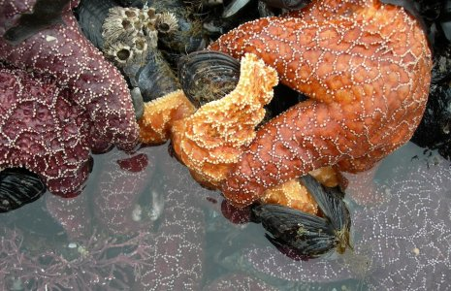
Ochre seastars (Pisaster ochraceus) feed on mussels off the coast of Oregon.
Credit:
Susanne Skyrm/Marine Photobank
Generally, shelled animals—including mussels, clams, urchins and starfish—are going to have trouble building their shells in more acidic water, just like the corals. Mussels and oysters are expected to grow less shell by 25 percent and 10 percent respectively by the end of the century. Urchins and starfish aren’t as well studied, but they build their shell-like parts from high-magnesium calcite, a type of calcium carbonate that dissolves even more quickly than the aragonite form of calcium carbonate that corals use. This means a weaker shell for these organisms, increasing the chance of being crushed or eaten.
Some of the major impacts on these organisms go beyond adult shell-building, however. Mussels’ byssal threads, with which they famously cling to rocks in the pounding surf, can’t hold on as well in acidic water. Meanwhile, oyster larvae fail to even begin growing their shells. In their first 48 hours of life, oyster larvae undergo a massive growth spurt, building their shells quickly so they can start feeding. But the more acidic seawater eats away at their shells before they can form; this has already caused massive oyster die-offs in the U.S. Pacific Northwest.
This massive failure isn’t universal, however: studies have found that crustaceans (such as lobsters, crabs, and shrimp) grow even stronger shells under higher acidity. This may be because their shells are constructed differently. Additionally, some species may have already adapted to higher acidity or have the ability to do so, such as purple sea urchins. (Although a new study found that larval urchins have trouble digesting their food under raised acidity.)
Of course, the loss of these organisms would have much larger effects in the food chain, as they are food and habitat for many other animals.

Zooplankton
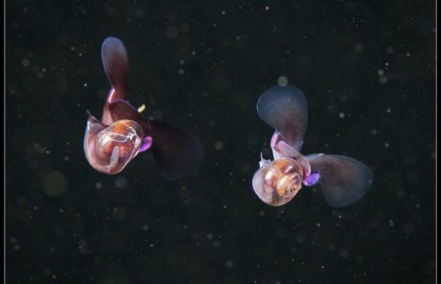
This pair of sea butterflies (Limacina helicina) flutter not far from the ocean's surface in the Arctic.
Credit:
Courtesy of Alexander Semenov, Flickr
There are two major types of zooplankton (tiny drifting animals) that build shells made of calcium carbonate:foraminifera and pteropods. They may be small, but they are big players in the food webs of the ocean, as almost all larger life eats zooplankton or other animals that eat zooplankton. They are also critical to thecarbon cycle—how carbon (as carbon dioxide and calcium carbonate) moves between air, land and sea. Oceans contain the greatest amount of actively cycled carbon in the world and are also very important in storing carbon. When shelled zooplankton (as well as shelled phytoplankton) die and sink to the seafloor, they carry their calcium carbonate shells with them, which are deposited as rock or sediment and stored for the foreseeable future. This is an important way that carbon dioxide is removed from the atmosphere, slowing the rise in temperature caused by the greenhouse effect.
These tiny organisms reproduce so quickly that they may be able to adapt to acidity better than large, slow-reproducing animals. However, experiments in the lab and at carbon dioxide seeps (where pH is naturally low) have found that foraminifera do not handle higher acidity very well, as their shells dissolve rapidly. One study even predicts that foraminifera from tropical areas will be extinct by the end of the century.
The shells of pteropods are already dissolving in the Southern Ocean, where more acidic water from the deep sea rises to the surface, hastening the effects of acidification caused by human-derived carbon dioxide. Like corals, these sea snails are particularly susceptible because their shells are made of aragonite, a delicate form of calcium carbonate that is 50 percent more soluble in seawater.
One big unknown is whether acidification will affect jellyfish populations. In this case, the fear is that they will survive unharmed. Jellyfish compete with fish and other predators for food—mainly smaller zooplankton—and they also eat young fish themselves. If jellyfish thrive under warm and more acidic conditions while most other organisms suffer, it’s possible that jellies will dominate some ecosystems (a problem already seen in parts of the ocean).

Plants and Algae
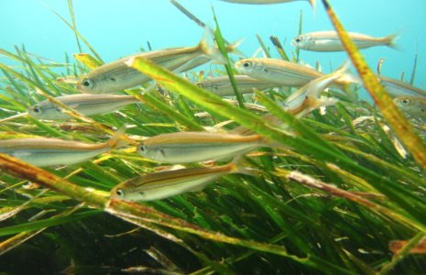
Neptune grass (Posidonia oceanica) is a slow-growing and long-lived seagrass native to the Mediterranean.
Credit:
Gaynor Rosier/Marine Photobank
Plants and many algae may thrive under acidic conditions. These organisms make their energy from combining sunlight and carbon dioxide—so more carbon dioxide in the water doesn't hurt them, but helps.
Seagrasses form shallow-water ecosystems along coasts that serve as nurseries for many larger fish, and can be home to thousands of different organisms. Under more acidic lab conditions, they were able to reproduce better, grow taller, and grow deeper roots—all good things. However, they are in decline for a number of other reasons—especially pollution flowing into coastal seawater—and it's unlikely that this boost from acidification will compensate entirely for losses caused by these other stresses.
Some species of algae grow better under more acidic conditions with the boost in carbon dioxide. But coralline algae, which build calcium carbonate skeletons and help cement coral reefs, do not fare so well. Most coralline algae species build shells from the high-magnesium calcite form of calcium carbonate, which is more soluble than the aragonite or regular calcite forms. One studyfound that, in acidifying conditions, coralline algae covered 92 percent less area, making space for other types of non-calcifying algae, which can smother and damage coral reefs. This is doubly bad because many coral larvae prefer to settle onto coralline algae when they are ready to leave the plankton stage and start life on a coral reef.
One major group of phytoplankton (single celled algae that float and grow in surface waters), thecoccolithophores, grows shells. Early studies found that, like other shelled animals, their shells weakened, making them susceptible to damage. But a longer-term study let a common coccolithophore (Emiliania huxleyi) reproduce for 700 generations, taking about 12 full months, in the warmer and more acidic conditions expected to become reality in 100 years. The population was able to adapt, growing strong shells. It could be that they just needed more time to adapt, or that adaptation varies species by species or even population by population.

Fish
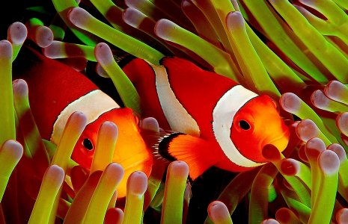
Two bright orange anemonefish poke their heads between anemone tentacles.
Credit:
Flickr user Jenny Huang (JennyHuang)/EOL
While fish don't have shells, they will still feel the effects of acidification. Because the surrounding water has a lower pH, a fish's cells often come into balance with the seawater by taking in carbonic acid. This changes the pH of the fish's blood, a condition called acidosis.
Although the fish is then in harmony with its environment, many of the chemical reactions that take place in its body can be altered. Just a small change in pH can make a huge difference in survival. In humans, for instance, a drop in blood pH of 0.2-0.3 can cause seizures, comas, and even death. Likewise, a fish is also sensitive to pH and has to put its body into overdrive to bring its chemistry back to normal. To do so, it will burn extra energy to excrete the excess acid out of its blood through its gills, kidneys and intestines. It might not seem like this would use a lot of energy, but even a slight increase reduces the energy a fish has to take care of other tasks, such as digesting food, swimming rapidly to escape predators or catch food, and reproducing. It can also slow fishes growth.
Even slightly more acidic water may also affects fishes' minds. While clownfish can normally hear and avoid noisy predators, in more acidic water, they do not flee threatening noise. Clownfish also stray farther from home and have trouble "smelling" their way back. This may happen because acidification, which changes the pH of a fish's body and brain, could alter how the brain processes information. Additionally, cobia (a kind of popular game fish) grow larger otoliths—small ear bones that affect hearing and balance—in more acidic water, which could affect their ability to navigate and avoid prey. While there is still a lot to learn, these findings suggest that we may see unpredictable changes in animal behavior under acidification.
The ability to adapt to higher acidity will vary from fish species to fish species, and what qualities will help or hurt a given fish species is unknown. A shift in dominant fish species could have major impacts on the food web and on human fisheries.

