Pedigree Charts
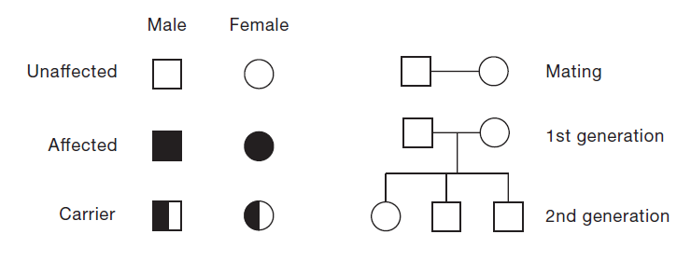
SYMBOLS

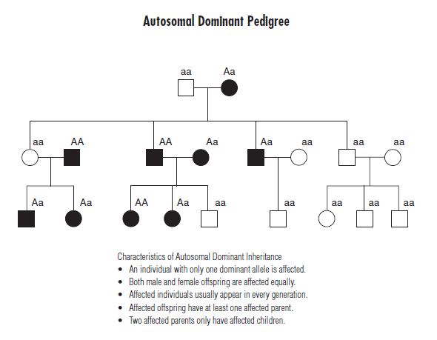
Aa

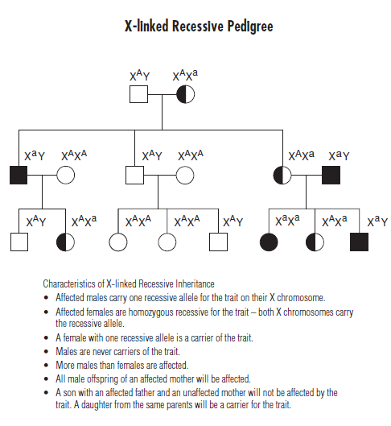

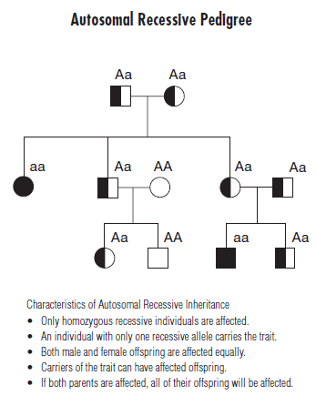

Prompt: Make and defend the claim for the inheritance pattern(s) found in Pedigrees A, B, and C. Write a short description of what you see in the chart using our unit vocabulary words. Be sure to include the type of disease shown in the chart, and who is most likely to be affected in the next generation. Bonus points if you can give me an example of a disease this family could be suffering from.

