Urinalysis labs

Your group will perform up to three tests on your patients’ Urine Sample in order to determine the disease that is affecting your patient.

Your patient may have any of the following results from their urine: High pH, low pH, positive for sugar, positive for protein, or your patients’ urine may be discolored. It could be that your patients’ urinalysis lab comes back with completely normal results.

Guidelines and expectations

Use gloves and goggles when handling all urine samples. When done, dispose of all pipettes and medicine cups in the trash and clean glass wear THOROUGHLY with soap and water.

Follow the instructions for each test and record your results in the results and analysis sheets.

Materials:

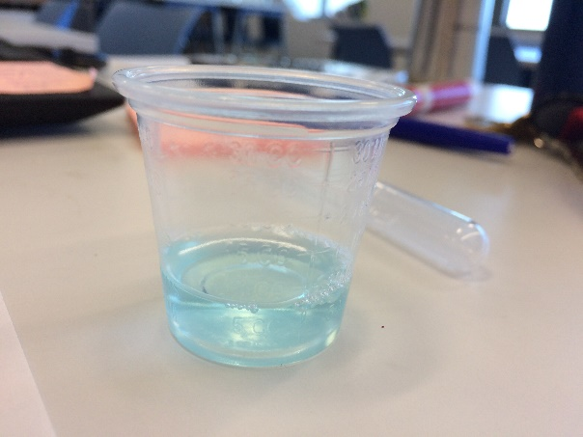
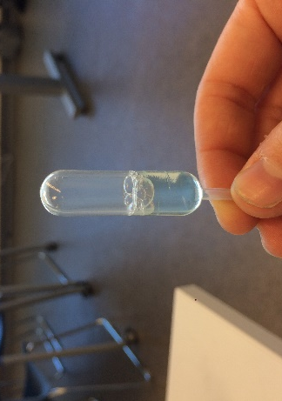
5mL urine sample. Take a small medicine cup and remove 5 mL from the large sample of your patient using a pipette.

This is 5 mL

This is 1 mL

2 test tubes and a test tube holder

1 pH strip and comparison chart

3mL Benedict’s solution in a pipette (Sugar)

1 ml Buriet solution in a pipette (Protein)

1 large plastic tray

You can keep your Buriet and Benedicts solutions in a pipette BUT DON’T MIX THEM UP! Use a post it, tape, or a marker to label them!

Test 1- pH

Take a pH test strip and dip one end of the pH strip in the 5mL urine sample.

Set down in the tray and wait ~ 30 seconds

Compare the color of the pH strip with the pH range on the comparison chart

Record your results in your “results and analysis chart”

**a urine sample positive for acid will be low pH, urine positive for alkaline will be high pH**

Test 2- Sugar

Put 3 ML of your urine sample into a test tube

Add 3 mL of Benedicts solution to the test tube

Place your test tube into the “Hot water Bath” on the back counter for two minutes

Remove the sample and record any color changes on your “results and analysis chart”

** a urine sample positive for sugar will turn a yellow to a red color**

Test 3- Protein

Put 3 mL of your urine sample into a clean test tube

Add 1 mL of the buriet solution to the test tube and swirl

Record the color into your “results and analysis chart”

**a sample positive for protein will result in an orange-red color, a negative reaction will result in a green color**

